The theme: “Cinema’’ 8 класс
Цель нашего урока: совершенствование лексических навыков по теме «Кино»
Задачи:
1) активизация тематической лексики в устной речи обучающихся;
2) расширение знаний обучающихся о кино;
3) развитие способности к логическому изложению, к догадке, коммуникабельности;
4) воспитание культуры человека посредством кино.
Организационный момент
- Good morning, boys& girls! Are you in a good mood?
- I think you are.
Now let’s start our lesson! Look at the screen, please!
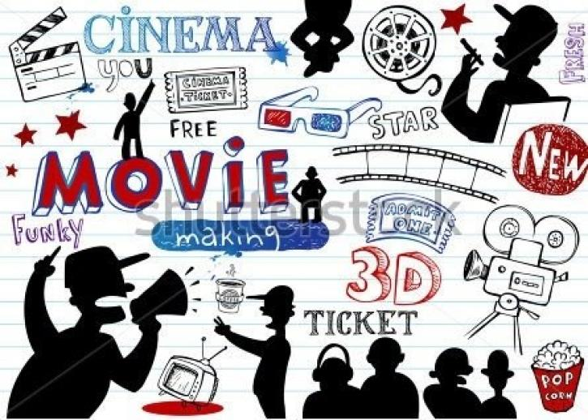

Now tell me what the theme of our lesson is?
Well done. The theme of our lesson is CINEMA! (1мин)
( на доске )
O. Wilde said: ”Art is the most intense mode of individualism that the world has known”.
( Let’s translate this statement by O. Wilde.)
Искусство — это самая выразительная из всех известных форм индивидуализма. (1мин)
Today we are going to speak about a very interesting kind of art. CINEMA!
Take your sheets of paper and repeat these words after me, please.
- western - вестерн
- horror film – фильм ужасов
- love story – фильм о любви
- historical film – исторический фильм
- fantasy film - фантастика
- thriller - триллер
- documentary film – документальный фильм
- comedy - комедия
- action film - боевик
- cartoon - мультфильм
- science fiction – научно-фантастический фильм
- feature film – художественный фильм
- musical – мюзикл
- drama – драма
- melodrama - мелодрама
- blockbuster – супербоевик, блокбастер.
Let’s read these words once more without translation.
(1 мин)
Answer my questions, children!
(Опрос. Жанры фильмов. Предпочтения.)
Do you like watching films?
Do you go to the cinema?
Do you watch films on TV or on a computer?
What genres do you know?
What is your favourite genre?
Do you like love story?
What is your favourite love story?
Did you watch the new Russian film “Вий”?
What is the genre of this movie?
(Thanks for your answers!!!)
Now I think you are tired. Stand up, please!
A relaxation break.
Imagine you are sculptors. Try to make up some figures. Show them on with helping your hands.
in shape/ shaped like– в форме
Show me
1.Something is shaped like a ball.
2. Something is shaped like a star.
3. Something is shaped like a heart.
4. Something is regular in shape.
5. Something is irregular in shape.
6. Something is shaped like a square.
7. Something is shaped like a triangle.
You are good sculptors.
Well done. Thank you.
I’m very glad that you like cinema. And I know that all of you have favourite actors and actresses. I’m ready to listen to your speeches. Who will be the first? You are welcome! Look at the screen! Рассказ о любимых актёрах. (3 человека) Thanks a lot for your stories. Let’ go on.
My dear, do you know about Oscar? What is Oscar?
Oscar is an award
Oscar is given to actors, writers, directors and producers.
Do you know what Russian films, directors were awarded by Oscar? Look at the screen, please. Read the title of the movie, translate it and name the genre of this film.
The first Oscar was given to the film by Vitali Suslenkov in 1942.
Sergei Bondarchuk got Oscar in 1968 for the film “War and peace”.
Vladimir Menshov - 1980 the film “Moscow doesn’t believe tears”
Nikita Mikhalkov. In 1994 his picture “Burn by the Sun” was awarded by Oscar too.
And at last in 2000 it was “The old man and the sea” that won this award.
4 минуты.
Read the text and answer the questions:
Everyone loves a good blockbuster film. They are exciting to watch and often use incredible special effects. Many of the greatest box office hits (кассовые хиты) of all time were made in the 1990s. They include Toy Story 2 (1999), Titanic (1997), and Jurassic Park (1993), to name a few. These films had huge budgets and took time to make. However, they also made a lot of money both for the studio and for the actors who starred in them. Russell Crowe was paid $15 million for his role in the 2000 blockbuster, Gladiator. After he won the Best Actor Oskar, he was able to demand as much as $20 million per film.
- When were many of the greatest box hits made?
- What box hits do they include?
- What film was a blockbuster in 2000?
- Who played the main role in this film?
- What prize did Russell Crowe win?
Complete the following sentences with the correct word.
blockbuster budget director producer
- The ________________ finds the money to pay for the film to be made.
- The________________ tells the actors and actresses what to do.
- A _________________ film is a successful film that costs a lot of money to make.
- The _______________ for a film is the amount(количество) of money spent making film. (4 мин)

- Если остаётся время, можно предложить учащимся составить всевозможные короткие слова из предложенного длинного, например, BLOCKBUSTER;
- Давайте вернёмся к цели нашего урока, которую мы поставили с вами в начале нашей работы. Совершенствование лексических навыков по теме «Кино». Как вы считаете, мы добились поставленной цели?
- Оценка и самооценка
Who | Remember new words
Who | Very well | Well | Not very well
I
Teacher
My Classmate
Синквейн.
T: I want you to write a сinkveyn.
Правила написания синквейна таковы:
На первой строчке записывается одно слово – существительное. Это и есть тема синквейна.
На второй строчке пишутся два прилагательных, раскрывающих тему синквейна.
На третьей строчке записываются три глагола, описывающих действия, относящиеся к теме синквейна.
На четвертой строчке размещается целая фраза, предложение, состоящее из нескольких слов, с помощью которого вы характеризуете тему в целом, выказываете свое отношение к теме. Таким предложением может быть крылатое выражение, цитата, пословица или составленная фраза в контексте с темой.
Пятая строчка – это слово-резюме, которое дает новую интерпретацию темы, выражает личное отношение к теме

